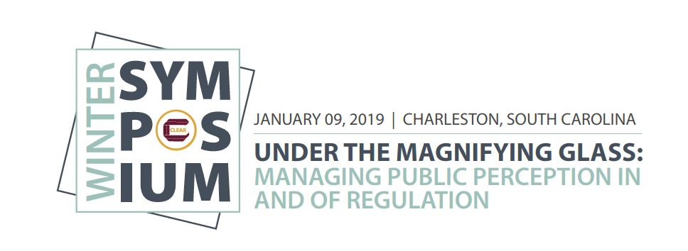

8:00 – 8:30 a.m. Registration

8:30 – 8:45 a.m. Welcome and Introductions
Bronwyn Clark, Chief Executive Officer, Australian Pharmacy Council Ltd

8:45 – 10:15 a.m. Moving from the Front Page to the Front of the Class: Crisis Management and the Regulator
Speakers: Michael Salvatori, Chief Executive Officer and Registrar, Ontario College of Teachers
Charlie Morrison, Manager, Policy & Research, Ontario College of Teachers

Drawing on the Ontario College of Teachers’ experience of overcoming the impact of negative media scrutiny of its disciplinary function, the presenters will briefly describe the context for the crisis and the inherent reputational risk. The presenters will subsequently outline the strategies and tactics successfully employed to manage the crisis to maintain public and government confidence in the College. The session will include an exercise in which participants will explore crisis scenarios in the regulatory realm and identify strategies and resources to successfully manage the crisis.

10:15 – 10:30 a.m. Break

10:30 – 11:15 a.m. Communicating and Using Social Media in a Regulatory Environment: Part A – Best Practices
Speaker: Randa Zalman, President and Chief Executive Officer, Canary & Coal and the Insurance Marketing Institute

As regulators and compliance executives there are many challenges and opportunities of social media and other new forms of digital and dynamic communication. In our Best Practices session, we’ll discuss:
- Reviewing Basic Social Media Principles
- Crafting Effective Social Media Policies
- Creating Content and Approval Processes and Procedures
- Setting Up Duty to Supervise Standards

11:15 a.m. – Engaging the Public
12:00 p.m. Speaker: Jimi Bush, Performance and Outreach Manager, Washington Medical Commission

What good is a great product or service if no one knows about it? Engaging the public, whether through public information, communication, campaigns, or education is a core function of most government organizations. In this presentation, the Washington Medical Commission will discuss their initial efforts to engage the public, provide strategies for continual engagement, and tips for re-energizing when an engagement campaign falls flat.

12:00 – 1:00 p.m. Lunch (provided) and Networking

1:00 – 2:15 p.m. Communicating and Using Social Media in a Regulatory Environment: Part B – Strategy and Tactics
Speaker: Randa Zalman, President and Chief Executive Officer, Canary & Coal and the Insurance Marketing Institute

In our Strategy and Tactics session, we’ll build on the previous “Engaging the Public” session by discussing:
      - Developing your own compliant blueprint for effective communication
      - Shaping internal and external key messages
      - Identifying opportunities to amplify engagement
      - Employing social media functionality for maximum reach

2:15 – 2:30 p.m. Break

2:30 – 3:15 p.m. The Challenge of Eliciting Meaningful Feedback from Stakeholders
Speakers: Ginny Hanrahan, CEO, CORU – Health & Social Care Professionals Council
Aoife Sweeney, Education Officer, CORU – Health & Social Care Professionals Council

Stakeholder engagement and feedback is crucial to the development of successful and appropriate policies in regulation. However, as regulation is a technical, complex topic it can be challenging to ensure feedback from stakeholders is meaningful and appropriate. This could be considered even problematic in multi-profession regulation. This session will present the CORU experience of engaging stakeholders during the development of a new framework for developing criteria and standards for the approval of education and training programs. Consideration will be given of how to consider and act on stakeholder feedback, especially in light of competing interests. Finally, should the regulator give feedback on the quality of feedback, will be considered.

3:15 – 4:00 p.m. Communicating and Using Social Media in a Regulatory Environment: Part C – Upcoming Trends
Speaker: Randa Zalman, President and Chief Executive Officer, Canary & Coal and the Insurance Marketing Institute

Now that you have a solid communications plan for the here and now, we’ll take a fun look at social media predictions for the future – what’s on the horizon so you can be prepared, maybe even impress your friends.

4:00 – 4:30 p.m. Q&A and Conclusion
End the day with a chance to interact with our speakers and get your burning questions answered from the experts.

